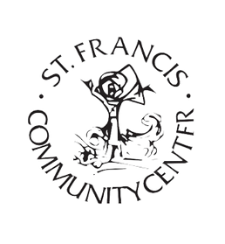
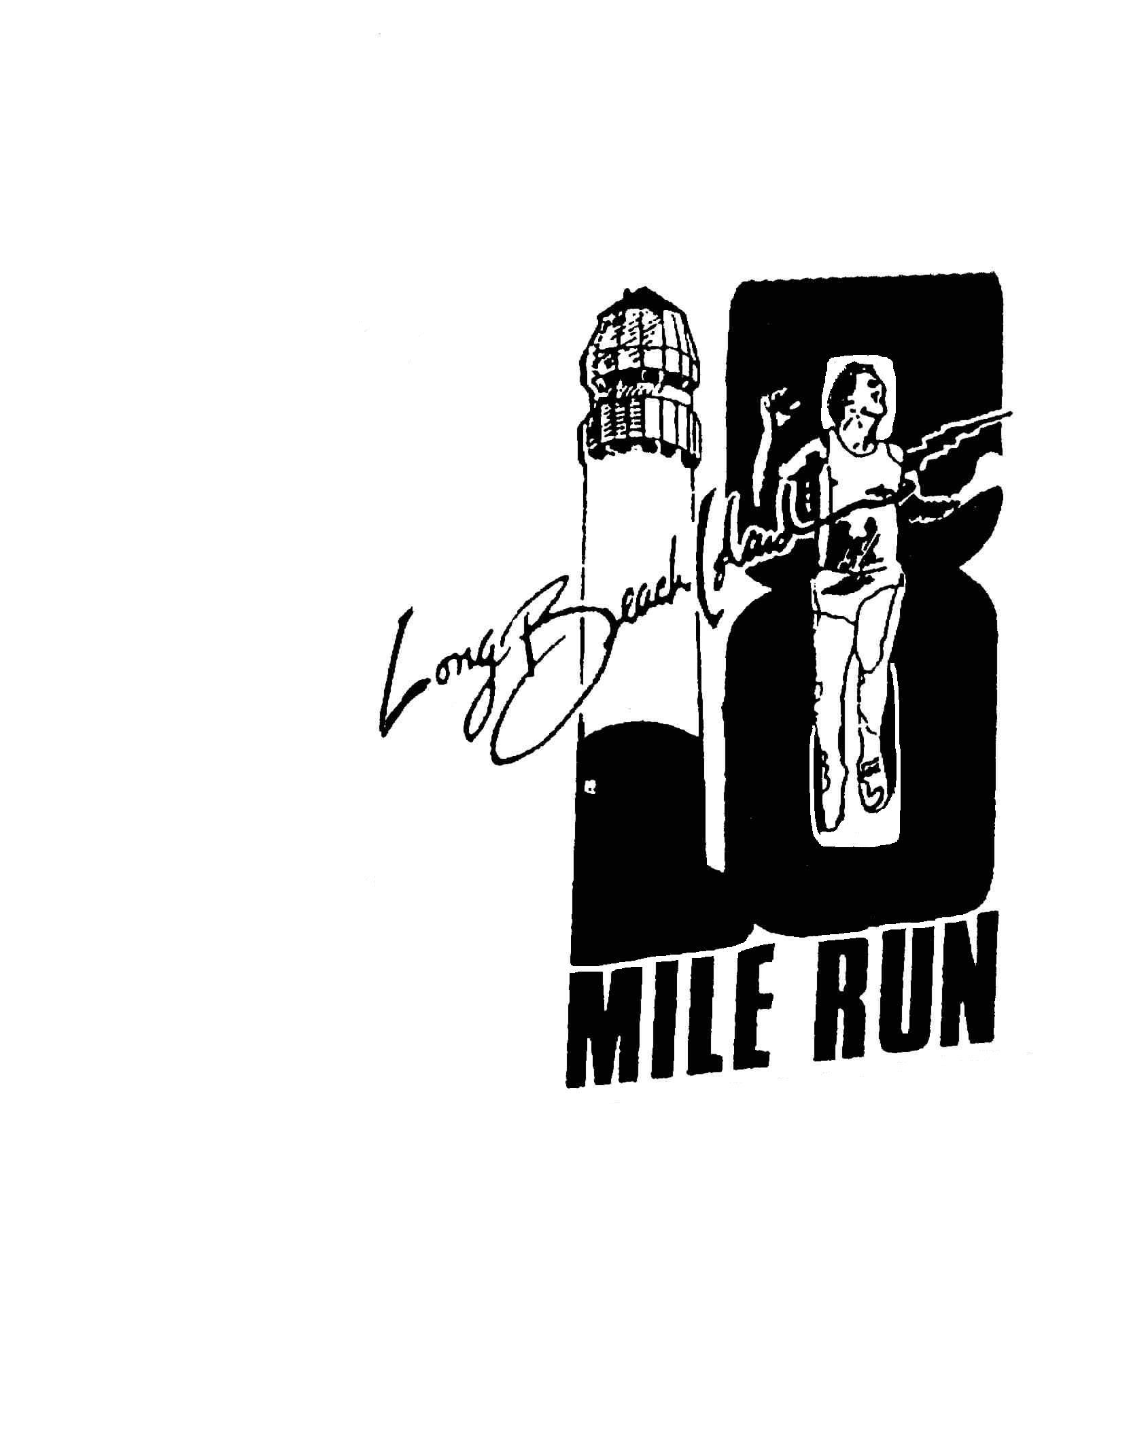
52nd Annual
L.B.I. COMMEMORATIVE
18-Mile Run
October 8, 2024

Check Appropriate Box

GRAND SPONSOR - $1500

Only 2 sponsorships available**

Your Business Name on a Banner at Final Race Marker

A Print Ad in the Official Race Booklet

An Official Run T-Shirt (indicate size) S M L XL

Please complete this form and return it with your check by 9/1/2024 to
Colleen Yerves, Recreation Coordinator, 4700 Long Beach Blvd., Long Beach Township, NJ 08008.

Make checks payable to: St. Francis Community Center

BRONZE SPONSOR - $150

Name Listed on Back of Event T-Shirt

An Official Run T-Shirt (indicate size) S M L XL

Sponsor Information

Sponsor Name: ______________________________________________________
(As you want it to appear on advertising)
Contact Person: ______________________________________________________

Address: _____________________________________________________________

Telephone: __________________________________________________________

Email: _________________________________________________

All 12K and 18 Mile Run Sponsors
Shared on Social media Platforms leading up to the race

SILVER SPONSOR - $300

Name Listed on Back of Event T-Shirt

A Print Ad in the Official Race Booklet

An Official Run T-Shirt (indicate size) S M L XL

GOLD SPONSOR - $500

Business Logo on Back of Event T-Shirt

Your Business Name on a Mile Marker

An Official Run T-Shirt (indicate size) S M L XL

